SIMATS ENGINEERING
ASSESSMENT TOOL 3
NAME:SIVARANGJENII B
REG NO: 192521375
COURSE NAME: COMPUTER NETWORKS
COURSE CODE: CSA07

COURSE OUTCOME COVERED
CO2: Configure IP addressing schemes, subnetting, and basic routing techniques
using simulation tool, for efficient network design and topology. (BL3)
Assessment Tool Weightage: 30%
Software:Cisco Packet Tracer,Wireshark

Annexure A
Debugging &amp; Optimisation Task
1. A network administrator has configured a workstation with the following settings:
• IP Address: 192.168.10.65
• Subnet Mask: 255.255.255.192 (/26)
• Default Gateway: 192.168.10.1
However, the workstation is unable to communicate with other systems configured in the subnet
192.168.10.0/26.
Task
Debug the network configuration by:
• Identifying the subnet to which the configured IP address belongs.
• Determining the network address, broadcast address, and valid host range.
• Verifying whether the configured IP address and gateway are valid.
• Identifying the configuration errors.
• Optimizing the configuration by assigning an appropriate IP address and default gateway.
• Calculating the total number of usable host addresses after correction.
2. Two devices are configured with the following IPv6 addresses:
• Device A: 2001:db8::ff00:42:8329/64
• Device B: 2001:db8:0:0:1::1/64
Although both devices are connected to the same network, communication fails.
Task
Debug the IPv6 configuration by:
• Expanding both IPv6 addresses into their complete notation.
• Determining the network prefix of each device.
• Verifying whether both devices belong to the same subnet.
• Identifying the addressing or prefix mismatch.
• Optimizing the IPv6 configuration by assigning appropriate addresses.
• Calculating the number of available host addresses within the corrected subnet.
3. An organization has allocated the network 192.168.1.0/24 into several departments using the
subnet masks /26, /27, and /28. Some departments report insufficient IP addresses, while others
have a large number of unused addresses.
Task
Analyze and optimize the subnet allocation by:
• Identifying the network address, broadcast address, and host range for each subnet.
• Calculating the number of usable and unused IP addresses.
• Identifying inefficient subnet allocations.
• Debugging the addressing plan by locating subnet allocation mistakes.
• Recommending an optimized subnetting scheme using VLSM to improve address
utilization while supporting current departmental requirements.
4. Two devices are configured with the following IPv6 addresses:
• Device A: 2001:db8::ff00:42:8329/64
• Device B: 2001:db8:0:0:1::1/64
Although both devices are connected to the same network, communication fails.
Task
Debug the IPv6 configuration by:
• Expanding both IPv6 addresses into their complete notation.
• Determining the network prefix of each device.
• Verifying whether both devices belong to the same subnet.
• Identifying the addressing or prefix mismatch.
• Optimizing the IPv6 configuration by assigning appropriate addresses.
• Calculating the number of available host addresses within the corrected subnet.
5. A router contains the following routing table.
Destination Network Next Hop
192.168.1.0/24 10.0.0.2
192.168.2.0/24 10.0.0.3
Default Route 10.0.0.1
Users report that packets destined for 192.168.2.100 are not reaching the intended network.
Task
Debug the routing configuration by:
• Identifying the matching routing entry using the longest-prefix match.
• Determining the next-hop router selected for packet forwarding.
• Verifying whether the destination IP belongs to the intended subnet.
• Identifying any routing configuration errors.
• Optimizing the routing table to improve packet forwarding efficiency.
• Identifying the route that will be used if no matching destination exists.
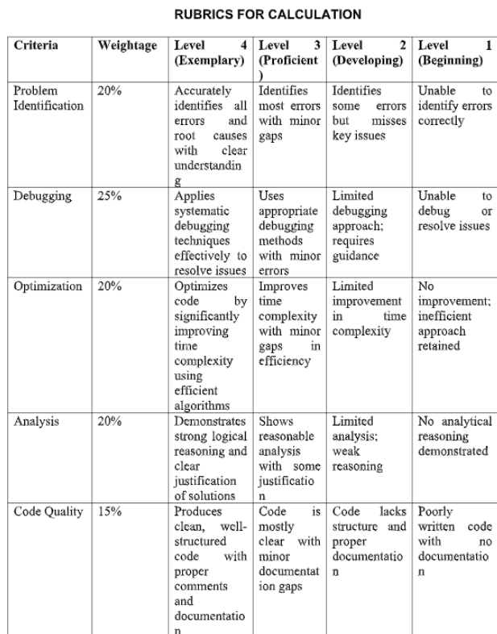

Question 1 – Debugging & Optimization of IPv4 Network Configuration
Given
- IP Address = 192.168.10.65
- Subnet Mask = 255.255.255.192 (/26)
- Default Gateway = 192.168.10.1
Step 1: Identify the Subnet
Subnet Mask = 255.255.255.192 (/26)
Block Size
= 256 − 192
= 64
Subnet Ranges:
- 192.168.10.0 – 192.168.10.63
- 192.168.10.64 – 192.168.10.127
- 192.168.10.128 – 192.168.10.191
- 192.168.10.192 – 192.168.10.255
The given IP address 192.168.10.65 falls within the range 192.168.10.64 – 192.168.10.127.
Therefore, the subnet is:
192.168.10.64/26
Step 2: Determine the Network Address
Network Address = 192.168.10.64
Step 3: Determine the Broadcast Address
The next subnet begins at 192.168.10.128.
Therefore,
Broadcast Address
= 192.168.10.127
Step 4: Determine the Valid Host Range
First Host
= 192.168.10.65
Last Host
= 192.168.10.126
Valid Host Range
= 192.168.10.65 – 192.168.10.126
Step 5: Verify the Configured IP Address
Configured IP Address
= 192.168.10.65
Since it lies within the valid host range, the IP address is valid.
Step 6: Verify the Default Gateway
Configured Gateway
= 192.168.10.1
This gateway belongs to subnet 192.168.10.0/26.
The workstation belongs to subnet 192.168.10.64/26.
Since they are in different subnets, the default gateway is invalid.
Step 7: Configuration Error
The configured default gateway belongs to a different subnet from the workstation.
Hence, the workstation cannot communicate with other devices in its subnet.
Step 8: Optimized Configuration
IP Address = 192.168.10.65
Default Gateway
= 192.168.10.66 (or any valid router IP between 192.168.10.65 and 192.168.10.126)
Step 9: Calculate the Total Number of Usable Hosts
Formula
= 2^(32 − 26) − 2
= 2^6 − 2
= 64 − 2
= 62 usable host addresses

Question 2 – Debugging & Optimization of IPv6 Configuration
Given
Device A
2001:db8::ff00:42:8329/64
Device B
2001:db8:0:0:1::1/64
Step 1: Expand the IPv6 Addresses
Device A
2001:0db8:0000:0000:0000:ff00:0042:8329
Device B
2001:0db8:0000:0000:0001:0000:0000:0001
Step 2: Determine the Network Prefix
Prefix Length
= /64
Network Prefix for Device A
= 2001:db8:0:0::/64
Network Prefix for Device B
= 2001:db8:0:0::/64
Step 3: Verify Whether Both Devices Belong to the Same Subnet
Both devices have the same /64 network prefix.
Therefore, they belong to the same subnet.
Step 4: Identify the Addressing or Prefix Mismatch
There is no IPv6 addressing or prefix mismatch.
The communication failure may be caused by:
- Incorrect default gateway
- Firewall blocking traffic
- Interface disabled
- Duplicate IPv6 address
- Neighbor Discovery failure
Step 5: Optimize the IPv6 Configuration
Device A
= 2001:db8:0:0::10/64
Device B
= 2001:db8:0:0::20/64
Default Gateway
= 2001:db8:0:0::1
Step 6: Calculate Available Host Addresses
Host Bits
= 128 − 64
= 64
Available Addresses
= 2^64
= 18,446,744,073,709,551,616 addresses

Question 3 – Analyze and Optimize the Subnet Allocation
Given Network
192.168.1.0/24
Subnet Masks Used
- /26
- /27
- /28
Step 1: Analyze the /26 Subnet
Network Address
= 192.168.1.0
Broadcast Address
= 192.168.1.63
Valid Host Range
= 192.168.1.1 – 192.168.1.62
Usable Host Addresses
= 62
Step 2: Analyze the /27 Subnet
Network Address
= 192.168.1.64
Broadcast Address
= 192.168.1.95
Valid Host Range
= 192.168.1.65 – 192.168.1.94
Usable Host Addresses
= 30
Step 3: Analyze the /28 Subnet
Network Address
= 192.168.1.96
Broadcast Address
= 192.168.1.111
Valid Host Range
= 192.168.1.97 – 192.168.1.110
Usable Host Addresses
= 14
Step 4: Calculate Unused Addresses
If a department requiring only 10 hosts receives a /26 subnet, then
Unused Addresses
= 62 − 10
= 52 unused IP addresses
This indicates inefficient subnet allocation.
Step 5: Debug the Addressing Plan
Possible subnet allocation mistakes include:
- Assigning a large subnet to a department with very few users.
- Assigning a small subnet to a department requiring many hosts.
- Overlapping subnet ranges.
- Incorrect subnet boundaries.
Step 6: Recommend an Optimized VLSM Scheme
Assign subnet sizes according to department requirements.
Example:
HR Department (50 hosts)
→ /26
Sales Department (25 hosts)
→ /27
Finance Department (10 hosts)
→ /28
This VLSM allocation minimizes address wastage and improves network efficiency.

Question 4 – Debugging IPv6 Configuration
Given
Device A
2001:db8::ff00:42:8329/64
Device B
2001:db8:0:0:1::1/64
Step 1: Expand the IPv6 Addresses
Device A
2001:0db8:0000:0000:0000:ff00:0042:8329
Device B
2001:0db8:0000:0000:0001:0000:0000:0001
Step 2: Determine the Network Prefix
Network Prefix
= 2001:db8:0:0::/64
Step 3: Verify Whether Both Devices Belong to the Same Subnet
Both devices belong to the same /64 network.
Step 4: Identify the Addressing Error
No IPv6 addressing mismatch exists.
Possible reasons for communication failure are:
- Incorrect default gateway
- Firewall restrictions
- Interface disabled
- Neighbor Discovery failure
Step 5: Optimize the Configuration
Device A
= 2001:db8:0:0::10/64
Device B
= 2001:db8:0:0::20/64
Gateway
= 2001:db8:0:0::1
Step 6: Calculate Available Host Addresses
Available Addresses
= 2^64
= 18,446,744,073,709,551,616 addresses

Question 5 – Debugging the Routing Configuration
Given Routing Table
192.168.1.0/24 → 10.0.0.2
192.168.2.0/24 → 10.0.0.3
Default Route → 10.0.0.1
Destination IP
= 192.168.2.100
Step 1: Identify the Matching Routing Entry
Destination IP
= 192.168.2.100
It matches the network
192.168.2.0/24
using the longest-prefix match.
Step 2: Determine the Next-Hop Router
Next Hop
= 10.0.0.3
Step 3: Verify the Destination Subnet
Network Address
= 192.168.2.0
Broadcast Address
= 192.168.2.255
Valid Host Range
= 192.168.2.1 – 192.168.2.254
The destination IP 192.168.2.100 lies within this range.
Therefore, the destination belongs to the intended subnet.
Step 4: Identify Routing Configuration Errors
Possible routing errors include:
- Incorrect next-hop IP address.
- Next-hop router is unreachable.
- Interface is down.
- Missing return route.
Step 5: Optimize the Routing Table
Ensure that:
- The next-hop router 10.0.0.3 is reachable.
- Interfaces are active.
- Return routes are correctly configured.
This improves packet forwarding efficiency.
Step 6: Route Used if No Matching Destination Exists
If no routing entry matches the destination, the router forwards the packet using the Default Route (10.0.0.1).

